

**FPT ACADEMY INTERNATIONAL**

**FPT – APTECH COMPUTER EDUCATION**

**ACE-HCMC-2-FPT**

**590 Cach Mang Thang 8, District 3, Ho Chi Minh City, Viet Nam**



travelola

Project Report Semester 4

|  |  |  |
| --- | --- | --- |
| **Supervisor** | Ngo Phuoc Nguyen | |
| **Batch** | T1.2008.M0 | |
| **Group** | 4 | |
| **Serial No.** | **Student Name** | **Enrollment No** |
| 1. | Nguyen Ngoc Hung | Student1273007 |
| 2. | Phung Hoai Bao | Student1273009 |
| 3. | Nguyen The Long | Student1273008 |
| 4. | Pham Van Nguyen | Student127300 |

Contents

Table of Contents

ACKNOWLEDGEMENT 2

REVIEW 1 3

INTRODUCTION 4

PROBLEM DEFINITION 6

CUSTOMER REQUIREMENT SPECIFICATION 8

SCOPE OF WORK 11

SYSTEM REQUIREMENT SPECIFICATION 13

Hardware 13

Web Server 13

Client 13

Software: 13

Web Server 13

Client 13

TASK SHEET REVIEW 1 15

REVIEW 2 16

DATA FLOW DIAGRAM 17

Architecture and Design of the System: 18

I. Context Level Diagram: 19

II. First Level DFD: 20

III. DFD for Booking Cycle 23

Sequence diagram 24

I. Login Function: (Users / Supplier) 24

II. Signup Function for customers: (User / Supplier) 26

III. Searching data function: 28

IV. View data function: 30

V. Insert/update/delete data function: 31

VI. Booking data function 32

ENTITY RELATIONSHIP DIAGRAM 33

TABLE DESIGN 34

I. Table Users: 34

II. Table user role 34

III. Table role 35

IV. Table Categories 35

V. Table Location 35

VI. Table District 36

VII. Table Province 36

VIII. Table Ward 37

IX. Table hotel 37

X. Table image 38

XI. Table room 38

XII. Table hotel booking 39

XIII. Table hotel feedback 40

Site Maps 40

I. User site: 40

II. Supplier: 41

III. Admin: 41

TASK SHEET REVIEW 2 42

REVIEW 3 44

# **ACKNOWLEDGEMENT**

Our group would like to devote this chapter to express our appreciation to all those who always offered us valuable assistance during in carrying out this project.

First and foremost, we owe a debt of gratitude to our dedicated instructor, Mr. Ngo Phuoc Nguyen, whose suggestions and encouragement helped us to overcome not only technological challenges but also psychological tension. Without him, our work could not have been completed successfully.

Secondly, we highly appreciate the project Team at the Head Office which has provided us a golden opportunity to apply what we learned into practice. We are certain that the experiences we gained from this project will facilitate our future career greatly. Besides, we would also like to express my gratitude to all the staff members of my center for not only providing me with the opportunity to work with them on this project, but also for their support and encouragement throughout the process.

Finally, we wish to say a personal thank you to all our dear classmates and team members who are always willing to support us openly and enthusiastically.

# **REVIEW 1**

# **INTRODUCTION**

During the period of information technology and computer development people can search and find anything at home vie internet connection and use online services. Therefore, we are developing a service “Book any hotel online with more conveniences” named Travel Booking App.

Travel Booking App is a group of people who wants to develop an online site where the users who are too busy to think of how they can purchase ticket online for traveling and this is also a marketing channel for hotels and airlines who will supply products for sale. It will provide users and suppliers the following features.

**For Travel Booking App’s customers:**

* Provide an interactive GUI, on the World Wide Web for the user.
* User can sign up, login, logout, change password, reset password on the website.
* User can search any hotel and the web will show them the hotel room available they refer before they book.
* User can review the hotel room that they booked and used.
* User can purchasing online vie payment online method as Pay-pal, stripe…
* User receive ticket with QR Scan code.
* User can see booking history.
* User can send feedback to admin or any question they have about Website or about their booking.
* User can see recommendation information.

**For Travel Booking App’s suppliers:**

* Hotel Suppliers can create, update, remove rooms.
* Supplies can sign up, login, logout, change password, reset password on the website.
* Suppliers can send mail to any feedback or question from customers.
* Suppliers reply review on website.
* Suppliers can check total booking, total purchased money from customers.

# **PROBLEM DEFINITION**

After reading the project specifications of travelola, our team had discussed about what should to be done to fulfil their requirements properly and we came to conclusion that in order to achieve the best result, we should deal with following queries:

**From the view point of users**

1. How can customer book the hotel’s room?
2. How can customer find the room they want?
3. How does customer keep track their history booking that they booked?
4. How can customers review room they used?
5. How can customers use login, signup, and logout?
6. How can customers make a payment?
7. How can customers send feedback to our website?

**From the view point of the Supplier**

1. How can hotel suppliers create, update, delete room?
2. How can suppliers see bookings history? And total payments?
3. How can suppliers use login, and logout?
4. How can suppliers send e-mail directly to customers in order to answer questions and send ticket confirmation?
5. How can suppliers receive payment?

**From the view point of the Administrator**

1. Will the systems be able to check the validity of users’ information before saving into the database?
2. How can Admin receive payment from customer and send % payment to suppliers?
3. How can Admin check feedback and reply feedback to customers?
4. How can Admin reply review from customers?
5. How can Admin check total bookings made from customers?

# **CUSTOMER REQUIREMENT SPECIFICATION**

**Client:** travelola

**Business/Project Objective:** The project is to design a service online for booking hotels and recommend hotels on same destination.

**Input to the system:**

**Travel Booking App’s admin need to provide:**

* Information required in order to create account to access to the admin system.

**Travel Booking App’s website suppliers need to provide:**

* Company information to create supplier account.
* Information about hotel going to be shown on website.

**Travel Booking App’s website customers need to provide:**

* Personal information to create an account.

**Output from the system:**

**Travel Booking App’s admin will be able to:**

* Login/Logout to the admin system.
* Manage (view, search, update, and delete) hotel’s rooms.
* Manage (view, search, active/ deactive) registered customers.
* Manage (view, search, active/ deactive) suppliers.
* Manage (view, search, reply, delete) reviews.
* Manage (view, search, reply, delete) feedbacks.

**Travel Booking App’s suppliers will be able to:**

* Login, Logout, Change password, Reset password.
* View, edit their information, room’s images.
* For hotels: Manage (view, search, update, and delete) hotel’s rooms.
* Manage (view, reply) about hotel’s room reviews.
* View their rating.
* View total bookings from customers.
* Manage (view, send email) reply feedback from customer.

**Travel Booking App’s customers will be able to:**

* If customers are guests:
  + Search hotel, destination or date they want to book.
  + View hotel information.
  + View review, rating about airline and hotel.
  + Can sign up to become member.
* If customers are registered members:
* Login, Logout, change Password, reset Password.
* Book hotel.
* View booking history.
* Search hotel by date, destination.
* Review hotel and make rating.
* Change personal information.
* Make a payment online.
* Receive booking confirmation and QR Scan code ticket.
* View Recommendation product that system suggest base on destination, date available or high rating.

# **SCOPE OF WORK**

The application should perform the following functions:

**Login:**

* There are 3 types of account in the application (“admin”, “supplier” and “user”). Admin will login as “admin”, Supplier will login as “supplier” and Customer will login as “user”.
* Three accounts must be registered and login for using the functionality of the application.
* For “admin”: can view/update customer profile, supplier information.
* For “supplier”: can update their information, update images, change their password, reset password.
* For “user”: can update profile, change password, reset password, register new account.

**Booking hotel’s room:**

* When users choose a hotel’s room available, website process them to payment checkout view for purchasing.

**Review hotel:**

* When user search for a hotel, they can see reviews and rating about that hotel.

**Database**

* The information about hotels, bookings, reviews will be stored in the database, and users can view on the Web or Mobile app

**Security:**

* The user password will be encrypted and stored in the database.

# **SYSTEM REQUIREMENT SPECIFICATION**

## **Hardware**

### Web Server

|  |  |
| --- | --- |
| Processor | Intel Core i5 or higher. |
| Memory | 4 GB RAM or greater. |
| Modem/ADSL | Connecting to internet 24/24 |

### Client

|  |  |
| --- | --- |
| Processor | Intel Core i3 or higher. |
| Memory | 2 GB RAM or greater. |
| Monitor | Super VGA (1024x768) or higher resolution |
| Modem/ADSL | Connecting to internet |

## **Software:**

### Web Server

|  |  |
| --- | --- |
| Operation System | Windows 7 or higher |
| Browser | Chrome version 35 or Microsoft Edge. |
| Database | SQL Server |
| Software | Internet Information Service |
| JAVA |
| Spring Boot |

### Client

|  |  |
| --- | --- |
| Operation System | Windows 7 or higher |
| Browser | Chrome version 35 or Microsoft Edge. |

**2.1 Development software**

* + Microsoft Windows 10
  + SQL Server
  + Google Chrome or Microsoft Edge
  + Git
  + Visual Studio Code
  + Postman

**2.2 Technology**

* Angular
* Javascript
* jQuery
* Flutter
* Firebase
* Bootstrap
* Java Spring boot, Spring Web.
* JWT security.

# **TASK SHEET REVIEW 1**

|  |  |  |  |  |  |  |  |
| --- | --- | --- | --- | --- | --- | --- | --- |
| **Project Ref. No.:**  **TRAVEL To VN** | | **Project Title:** | **Activity Plan Prepared By:** | **Date of Preparation of Activity Plan:** | | | |
| **Sr.No.** | **Task** | **Actual Start Date** | **Actual Days** | **Team Mate Names** | **Status** |
| 1 | Introduction and Problem Definition | travelola | Nguyen Ngoc Hung | 13/06/2022 | 1 | - Nguyen Ngoc Hung  - Phung Hoai Bao  - Nguyen The Long  - Pham Van Nguyen | 100% |
| 2 | Customer Requirement Specification (CRS) | 13/06/2022 | 1 | 100% |
| 3 | Functional Requirement | 13/06/2022 | 1 | 100% |
| 4 | System Requirement Specification | 100% |

# **REVIEW 2**

# **DATA FLOW DIAGRAM**

## Architecture and Design of the System:

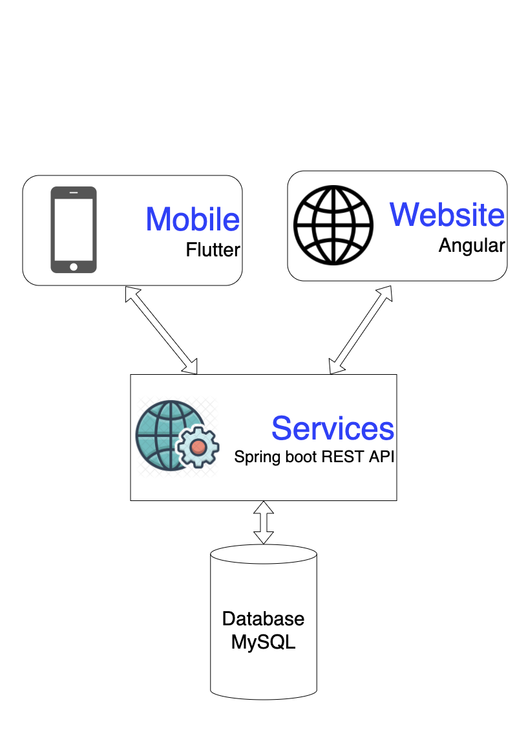

## Context Level Diagram:

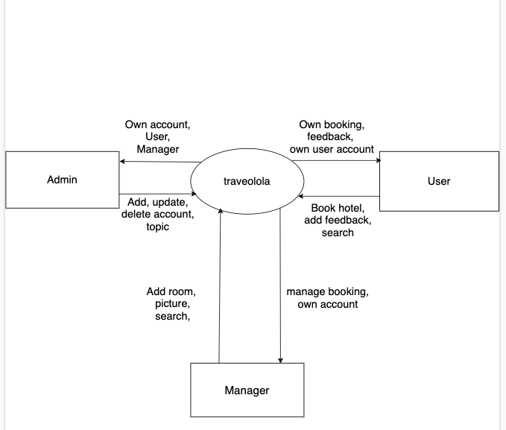

## First Level DFD:

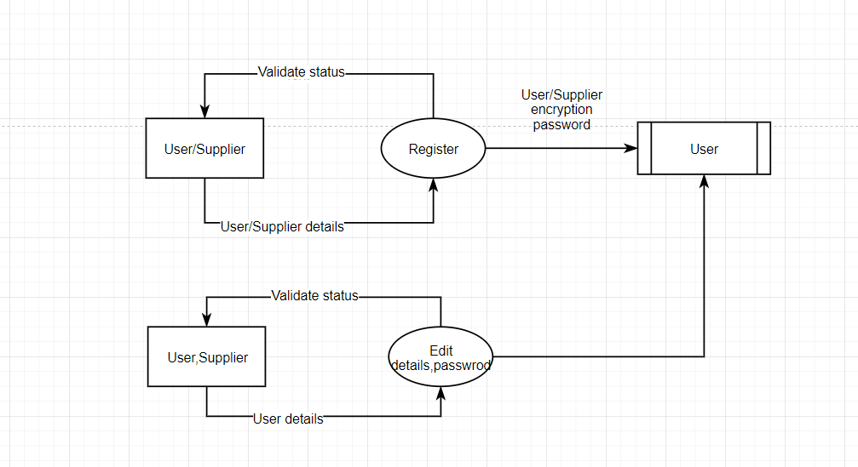

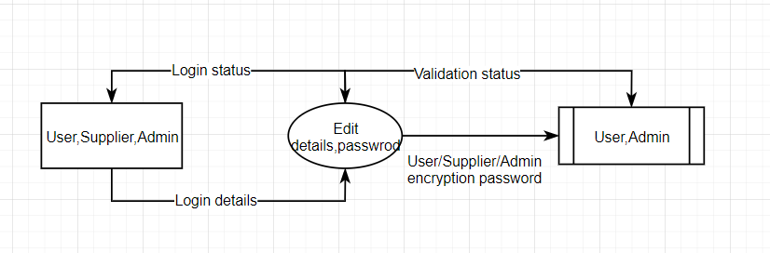

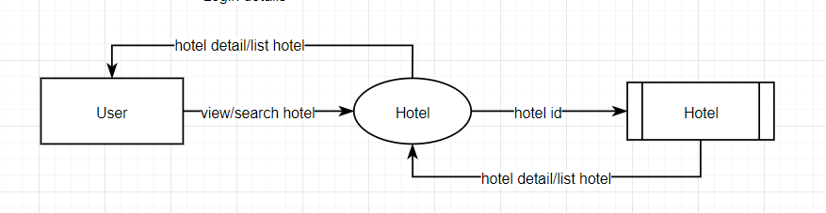

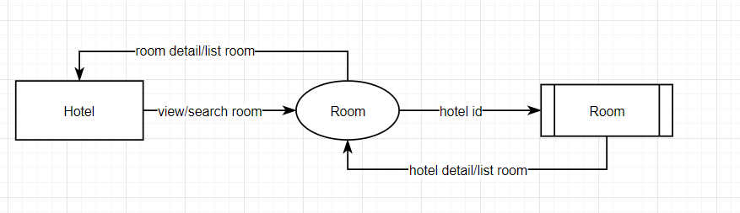

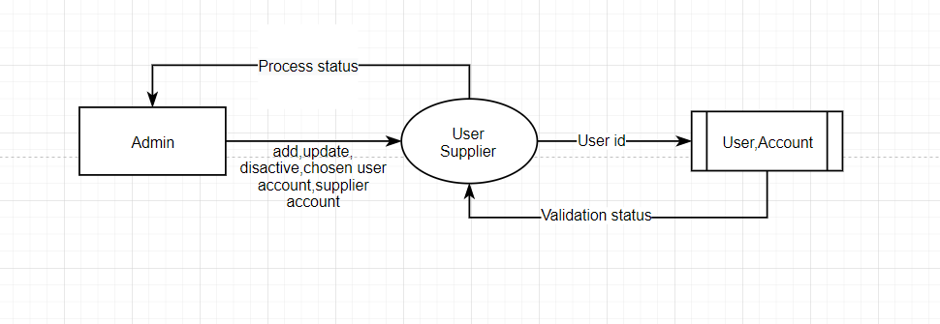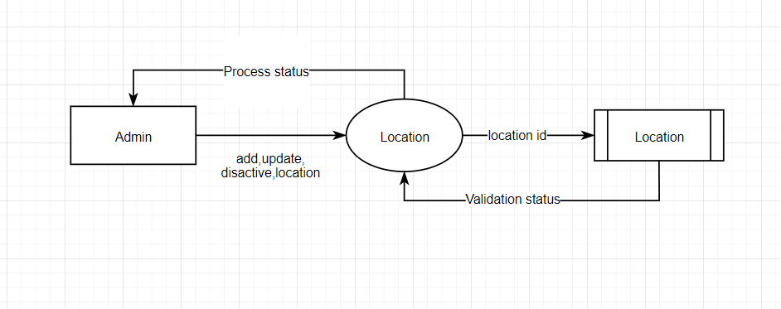

## DFD for Booking Cycle

# **Sequence diagram**

## Login Function: (Users / Supplier)

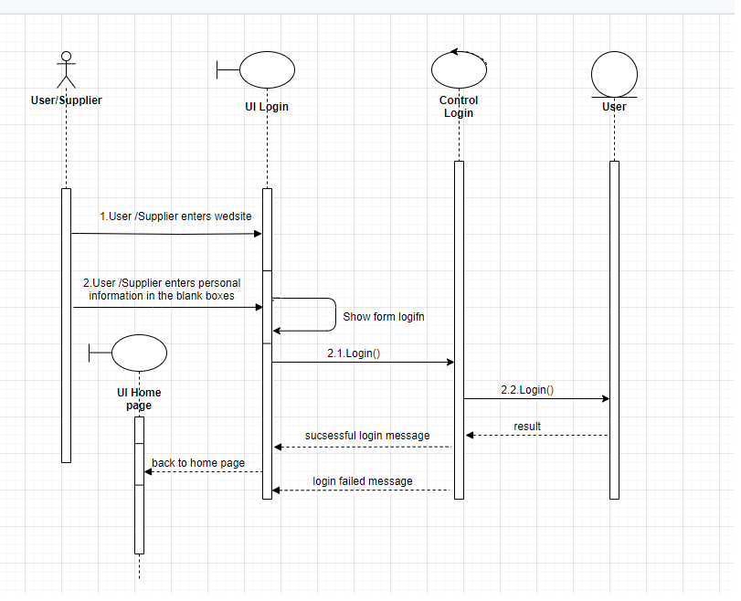

|  |  |  |
| --- | --- | --- |
| **Use Case Name** | Login – login button | |
| **Actors** | User and Supplier | |
| **Description** | When the user clicks the log button, Sparrow will open a popup page asking the user to enter login information | |
| **Requirements** | Username and Password can’t be blank. | |
|  | **User and Supplier Actions** | **System Responses** |
| **Basic flow** | 1. User and Supplier input user name and password | 2. System check the input string [Exception 1]  3. The system will check if, user exists or not and return the result  4.If yes, the screen will show login success, otherwise it will report invalid user. |
| **Exception** | 1. User or Supplier left the input Username empty | 1. An error message will be display: “Username can’t be blank” |
|  | 2. User or Supplier left the input Password empty | 1. An error message will be display: “Password can’t be blank” |

## Signup Function for customers: (User / Supplier)

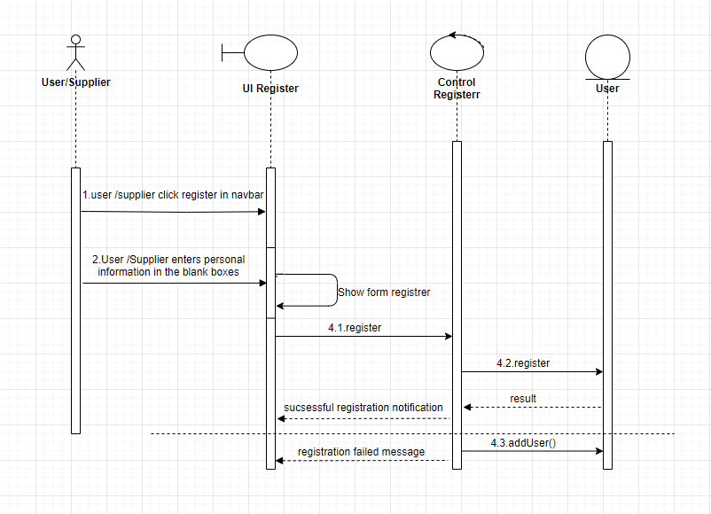

|  |  |  |
| --- | --- | --- |
| **Use Case Name** | Register – Register button | |
| **Actors** | User and Supplier | |
| **Description** | When the user clicks register, it goes to the register page for the user to register, input register information | |
| **Requirements** | first name, last name, user name, email, password, confirm password can’t be blank. | |
|  | **User and Supplier Actions** | **System Responses** |
| **Basic flow** | 1. User and Supplier input first name, last name, user name, email, password, confirm password | 2. System check the input string [Exception 1]  3. The system will check if, user exists or not and return the result  4.If yes, the screen will show register success, otherwise it will report invalid user. |
| **Exception** | 1. User or Supplier left the input Username empty | 1. An error message will be display: “Username can’t be blank” |
|  | 2. User or Supplier left the input Password empty | 1. An error message will be display: “Password can’t be blank” |

## Searching data function:

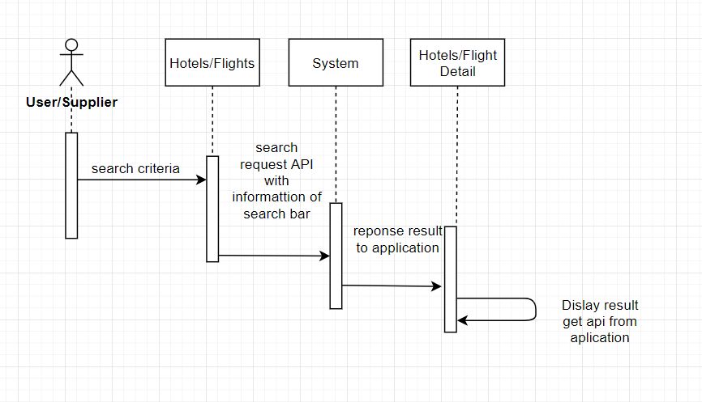

|  |  |  |
| --- | --- | --- |
| **Use Case Name** | Search – Search button | |
| **Actors** | User and Supplier | |
| **Description** | When search button is clicked, search result page will be displayed with result list of products and their information | |
| **Requirements** | Search string can’t be blank. | |
|  | **Actor Actions** | **System Responses** |
| **Basic flow** | 1. Actor input search string and input after that click on search button. | 2. System check the search string [Exception 1]  3. System create an empty list to contain search result.  4. Search in Products table to find products which have names contain the search string (ignore case) and add them to result list.  5. Display the result list in the search result page. |
| **Exception** | 1. Actor left the search string empty | 1. An error message will be display: “Search string can’t be empty” |

## 

## View data function:

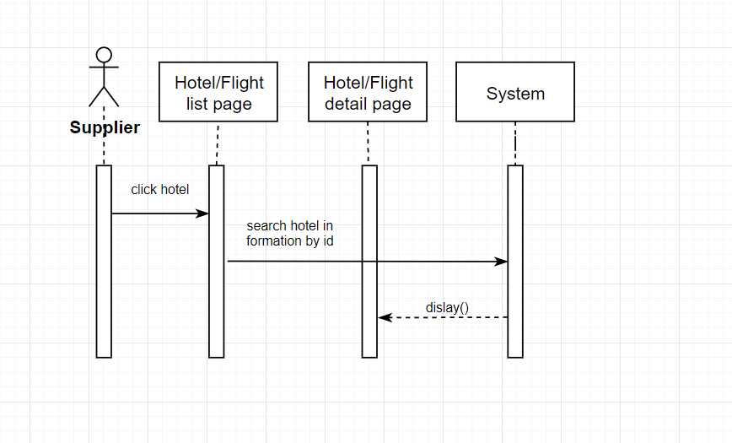

|  |  |  |
| --- | --- | --- |
| **Use Case Name** | View supplier details | |
| **Actors** | User and Supplier | |
| **Description** | Allows users to view all hotels that match the user's criteria and have pagination for optimization | |
| **Requirements** | Hotels can click to go to the detail page to view hotel information | |
|  | **Actor Actions** | **System Responses** |
| **Basic flow** | 1. Clicks on supplier item | 2. Information search with the input data.  3. Display hotel in the hotel detail page. |

## Insert/update/delete data function:

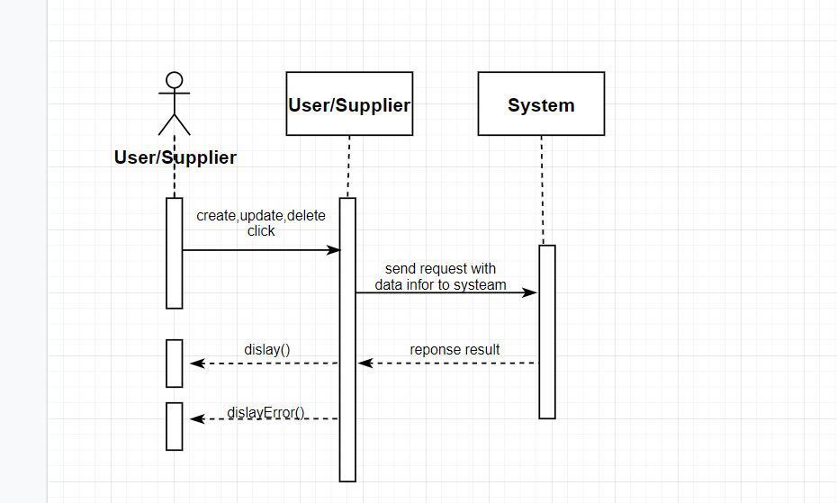

|  |  |  |
| --- | --- | --- |
| **Use Case Name** | Insert, update, delete supplier details | |
| **Actors** | Supplier | |
| **Description** | Supplier can insert, update, delete their data here, in addition, there is also pagination and filter here. | |
| **Requirements** | Users can view old data as well as update and delete unnecessary data | |
|  | **Actor Actions** | **System Responses** |
| **Basic flow** | 1. Clicks on supplier item list button like edit or delete | 2.Get the data input and do action on the sever.  3. Check the action if it is created or update, then validate the require and columns to show the user, if it is deleted, the message will be displayed.  4. Display notification when success or error. |

## Booking data function

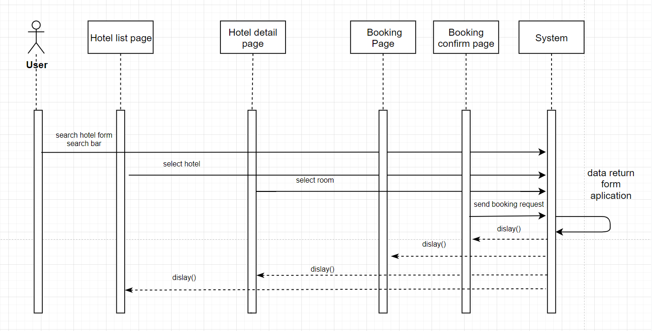

|  |  |  |
| --- | --- | --- |
| **Use Case Name** | Booking Room Action | |
| **Actors** | User only | |
| **Description** | Users can use the search engine on the home page to find the right hotel, then proceed to select the hotel and select the appropriate room to proceed with booking. | |
| **Requirements** | 1.Check in date, check out date and location can’t be blank.  2. must choose the number of rooms suitable for the number of people moving to the hotel.  3.Check out date greater than check in date.  4.Only user role can create booking | |
|  | **Actor Actions** | **System Responses** |
| **Basic flow** | 1. select location, check in date check out date, number adult and children to search  2.Into detail page click book now in room item select  3.into booking page click validate to validate information of user and open payment method | 1.Get the data input and do action search. Display item hotel result  2.Get data end search information of user. Display in Booking confirm page  3.Validate information of user and display payment method popup. After payment create book with data booking of user and show booking information at booking confirm page |

# **ENTITY RELATIONSHIP DIAGRAM**

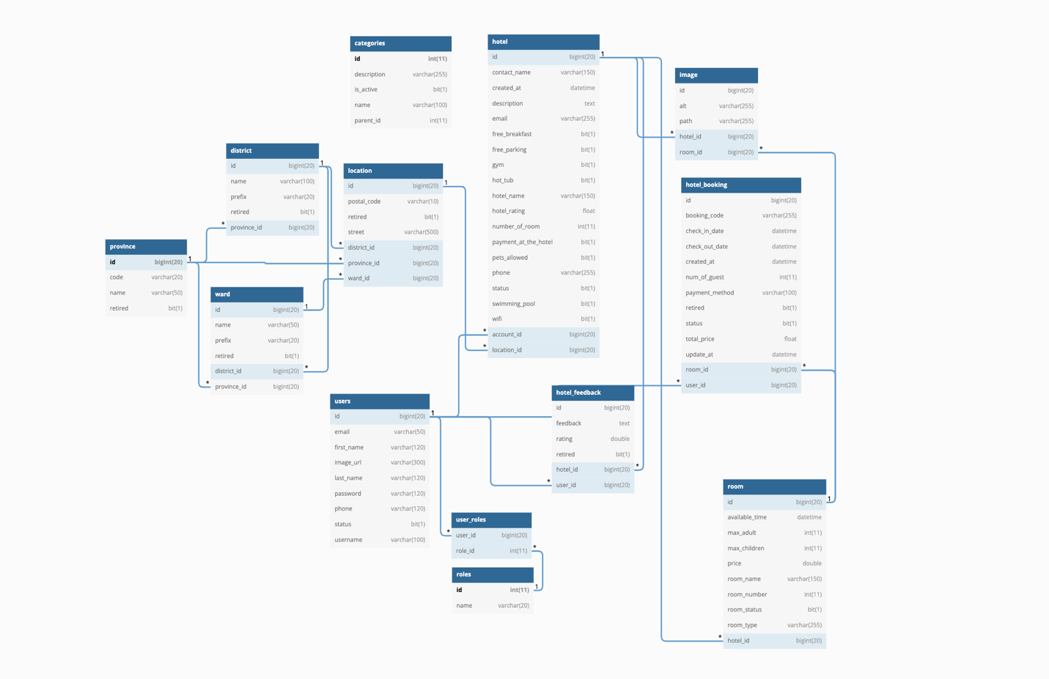

# **TABLE DESIGN**

## Table Users:

|  |  |  |  |  |  |  |
| --- | --- | --- | --- | --- | --- | --- |
| **Users** | | | | | | |
| **Field Name** | **Data Type** | **Null** | **Default Value** | **Key** | **Table-Field-Ref** | **Description** |
| ID | bigint | No |  | PK | Identity | Stores user id |
| First Name | Character varying (100) | No |  |  |  | Stores user first name |
| Last Name | Character varying (100) | No |  |  |  | Stores last name |
| Phone | Character varying (255) | No |  |  |  | Stores user phone number |
| Status | boolean | No | true |  |  | Active check |
| Image url | bigint | No |  |  |  | Stores user image |
| Username | Character varying (255) | No |  | FK |  | Stores username of user |
| Password | Character varying (255) | No |  | FK |  | Stores Password of user |
| Email | Character varying (255) | No |  | FK |  | Stores Email of user |

## 

## Table user role

|  |  |  |  |  |  |  |
| --- | --- | --- | --- | --- | --- | --- |
| **Users** | | | | | | |
| **Field Name** | **Data Type** | **Null** | **Default Value** | **Key** | **Table-Field-Ref** | **Description** |
| User_id | bigint | No |  |  |  | Stores user id |
| Role_id | int | No |  |  |  | Stores role id |

## Table role

|  |  |  |  |  |  |  |
| --- | --- | --- | --- | --- | --- | --- |
| **Users** | | | | | | |
| **Field Name** | **Data Type** | **Null** | **Default Value** | **Key** | **Table-Field-Ref** | **Description** |
| id | bigint | No |  | PK |  | Stores role id |
| name | int | No |  |  |  | Stores role name |

## Table Categories

|  |  |  |  |  |  |  |
| --- | --- | --- | --- | --- | --- | --- |
| **Users** | | | | | | |
| **Field Name** | **Data Type** | **Null** | **Default Value** | **Key** | **Table-Field-Ref** | **Description** |
| id | bigint | No |  | PK |  | Stores categories id |
| Description | Varchar(255) |  |  |  |  | Stores description |
| Is_active | Bit(1) |  |  |  |  | Store active status |
| Name | Varchar(100) |  |  |  |  | Store categories name |
| Parent_id | Int |  |  |  |  | Store parent_id |

## Table Location

|  |  |  |  |  |  |  |
| --- | --- | --- | --- | --- | --- | --- |
| **Users** | | | | | | |
| **Field Name** | **Data Type** | **Null** | **Default Value** | **Key** | **Table-Field-Ref** | **Description** |
| id | bigint | No |  | PK |  | Stores id |
| Postal_code | Varchar(10) |  |  |  |  | Stores postal code |
| retired | Bit(1) |  |  |  |  | Store retired status |
| street | Varchar(255) |  |  |  |  | Store street |
| District_id | bigint |  |  |  |  | Store district_id |
| Province_id | Bigint |  |  |  |  | Store province_id |
| Ward_id | Bigint |  |  |  |  | Store ward_id |

## Table District

|  |  |  |  |  |  |  |
| --- | --- | --- | --- | --- | --- | --- |
| **Users** | | | | | | |
| **Field Name** | **Data Type** | **Null** | **Default Value** | **Key** | **Table-Field-Ref** | **Description** |
| id | bigint | No |  | PK |  | Stores id |
| name | Varchar(100) |  |  |  |  | Stores name |
| prefix | Varchar(120) |  |  |  |  | Store prefix |
| retired | Bit(1) |  |  |  |  | Store retired status |
| Province_id | bignint |  |  |  |  | Store province_id |

## Table Province

|  |  |  |  |  |  |  |
| --- | --- | --- | --- | --- | --- | --- |
| **Users** | | | | | | |
| **Field Name** | **Data Type** | **Null** | **Default Value** | **Key** | **Table-Field-Ref** | **Description** |
| id | bigint | No |  | PK |  | Stores id |
| Code | Varchar(100) |  |  |  |  | Stores code |
| Name | Varchar(120) |  |  |  |  | Store name |
| retired | Bit(1) |  |  |  |  | Store retired status |

## Table Ward

|  |  |  |  |  |  |  |
| --- | --- | --- | --- | --- | --- | --- |
| **Users** | | | | | | |
| **Field Name** | **Data Type** | **Null** | **Default Value** | **Key** | **Table-Field-Ref** | **Description** |
| id | bigint | No |  | PK |  | Stores id |
| Name | Varchar(50) |  |  |  |  | Stores name |
| Prefix | Varchar(20) |  |  |  |  | Store prefix |
| Retired | bit |  |  |  |  | Store retired status |
| District_id | bigint |  |  |  |  | Store district_id |
| Province_id | Bigint |  |  |  |  | Store province_id |

## Table hotel

|  |  |  |  |  |  |  |
| --- | --- | --- | --- | --- | --- | --- |
| **Users** | | | | | | |
| **Field Name** | **Data Type** | **Null** | **Default Value** | **Key** | **Table-Field-Ref** | **Description** |
| id | bigint | No |  | PK |  | Stores id |
| Contact_name | Varchar(150) |  |  |  |  | Stores contact_name |
| Created_at | Datatime |  |  |  |  | Store Created_at |
| Description | text |  |  |  |  | Store Description |
| Email | Varchar(150) |  |  |  |  | Store Email |
| Free_breakfast | bit |  |  |  |  | Store province_id |
| Free_parking | bit |  |  |  |  | Stores Free_breakfast status |
| Gym | bit |  |  |  |  | Stores gym status |
| Hot_tub | bit |  |  |  |  | Stores hot_tub status |
| Hotel_name | Varchar(150) |  |  |  |  | Stores hotel_name |
| Hotel_rating | float |  |  |  |  | Stores hotel_rating |
| Number_of_room | Int |  |  |  |  | Stores room number |
| Payment_at_the_hotel | Bit |  |  |  |  | Stores payment at hotel status |
| Pets_allowed | Bit |  |  |  |  | Stores pets allowed |
| Phone | Varchar(150) |  |  |  |  | Stores phone number |
| Status | Bit |  |  |  |  | Stores status |
| Swimming_pool | Bit |  |  |  |  | Stores swimming pool status |
| Wifi | Bit |  |  |  |  | Stores free wifi status |
| Account_id | Bigint |  |  |  |  | Stores account_id |
| Location_id | bigint |  |  |  |  | Stores location_id |

## Table image

|  |  |  |  |  |  |  |
| --- | --- | --- | --- | --- | --- | --- |
| **Users** | | | | | | |
| **Field Name** | **Data Type** | **Null** | **Default Value** | **Key** | **Table-Field-Ref** | **Description** |
| id | bigint | No |  | PK |  | Stores id |
| alt | Varchar(150) |  |  |  |  | Stores alt |
| path | Varchar(150) |  |  |  |  | Store image path |
| Hotel_id | Bigint |  |  |  |  | Store hotel_id |
| Room_id | bigint |  |  |  |  | Store room_id |

## Table room

|  |  |  |  |  |  |  |
| --- | --- | --- | --- | --- | --- | --- |
| **Field Name** | **Data Type** | **Null** | **Default Value** | **Key** | **Table-Field-Ref** | **Description** |
| id | bigint | No |  | PK |  | Stores id |
| Available_time | datatime |  |  |  |  | Stores available time |
| Max_adult | int |  |  |  |  | Store max adult number |
| Max_children | int |  |  |  |  | Store max children number |
| price | double |  |  |  |  | Store price |
| Room_name | Varchar(150) |  |  |  |  | Store room name |
| Room_number | Int |  |  |  |  | Stores room number |
| Room_staus | Bit |  |  |  |  | Stores room status |
| Room_type | Varchar(255) |  |  |  |  | Stores room type |
| Hotel_id | bigint |  |  |  |  | Stores hotel_id |

## Table hotel booking

|  |  |  |  |  |  |  |
| --- | --- | --- | --- | --- | --- | --- |
| **Users** | | | | | | |
| **Field Name** | **Data Type** | **Null** | **Default Value** | **Key** | **Table-Field-Ref** | **Description** |
| id | bigint | No |  | PK |  | Stores id |
| Booking_code | Varchar(150) |  |  |  |  | Stores booking code |
| Check_in_date | Datatime |  |  |  |  | Store check in date |
| Check_out_date | Datatime |  |  |  |  | Store check out date |
| Created_at | Datatime |  |  |  |  | Store created date |
| Num_of_guest | int |  |  |  |  | Store number of guest |
| Payment_method | Varchar(150) |  |  |  |  | Stores payment method |
| Retired | bit |  |  |  |  | Stores retired statsus |
| Status | bit |  |  |  |  | Stores status |
| Total_price | float |  |  |  |  | Stores total price |
| Update_at | datetime |  |  |  |  | Stores update at |
| Room_id | bigint |  |  |  |  | Stores room id |
| User_id | Bigint |  |  |  |  | Stores user id |

## Table hotel feedback

|  |  |  |  |  |  |  |
| --- | --- | --- | --- | --- | --- | --- |
| **Users** | | | | | | |
| **Field Name** | **Data Type** | **Null** | **Default Value** | **Key** | **Table-Field-Ref** | **Description** |
| id | bigint | No |  | PK |  | Stores id |
| feedback | text |  |  |  |  | Stores feedback |
| rating | double |  |  |  |  | Store rating |
| retired | bit |  |  |  |  | Store retired status |
| Hotel_id | bigint |  |  |  |  | Store hotel_id |
| User_id | bigint |  |  |  |  | Store user_id |

# **Site Maps**

## User site:

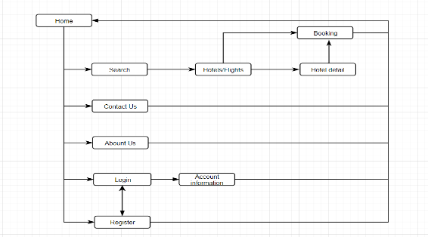

## II. Supplier:

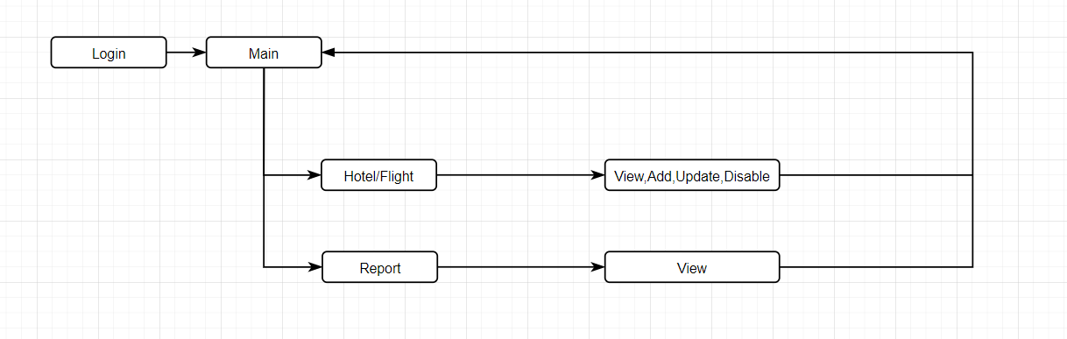

## III. Admin:

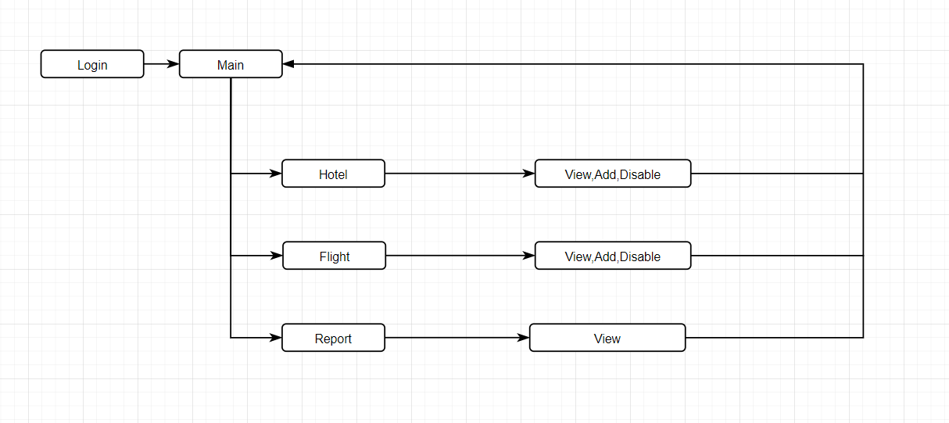

# **TASK SHEET REVIEW 2**

|  |  |  |  |  |  |  |  |
| --- | --- | --- | --- | --- | --- | --- | --- |
| **Project Ref. No.:**  **TRAVEL ToVN** | | **Project Title:** | **Activity Plan Prepared By:** | **Date of Preparation of Activity Plan:** | | | |
| **Sr.No.** | **Task** | **Actual Start Date** | **Actual Days** | **Team Mate Names** | **Status** |
| 1 | DFD (Data Flow Diagram) | **travelola** | Nguyen Ngoc Hung | 30/06/2022 | 1 | Nguyen The Long | 100% |
| 2 | Flowcharts | 30/06/2022 | 1 | Phung Hoai Bao | 100% |
| 3 | ERD (Entity Relationship Diagram) | 30/06/2022 | 1 | Nguyen Ngoc Hung | 100% |
| 4 | Table Design | 30/06/2022 | 1 | Pham Van Nguyen | 100% |

|  |  |
| --- | --- |
| **Date: 17/06/2022** | |
| Signature of Instructor:  **MR. NGO PHUOC NGUYEN** | Signature of Team Leader:  **Nguyen Ngoc Hung** |

# **REVIEW 3**

# **GUI DESIGN**

## HOME PAGE

## 

|  |  |  |  |  |  |
| --- | --- | --- | --- | --- | --- |
| **No** | **Name** | **Type** | **Validation** | **Description** | **Status** |
| 1 | Home | Click |  | Go home page | Enable |
| 2 | Contact | Click |  | Go contact page | Enable |
| 3 | Sign up | Click |  | Go sign up page | Enable |
| 4 | Login | Click |  | Go login page | Enable |
| 5 | Popular destinations | click |  | Find hotel with city | Enable |

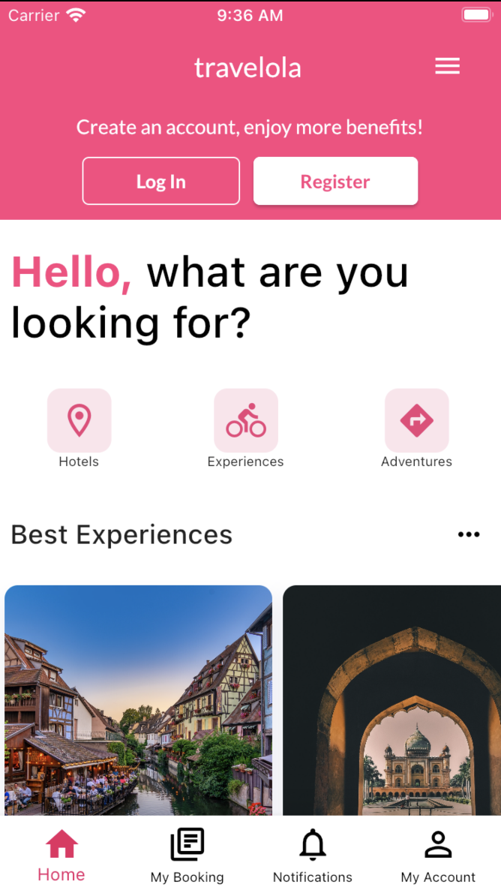

## SEARCH HOTEL PAGE

## HOTEL DETAILS

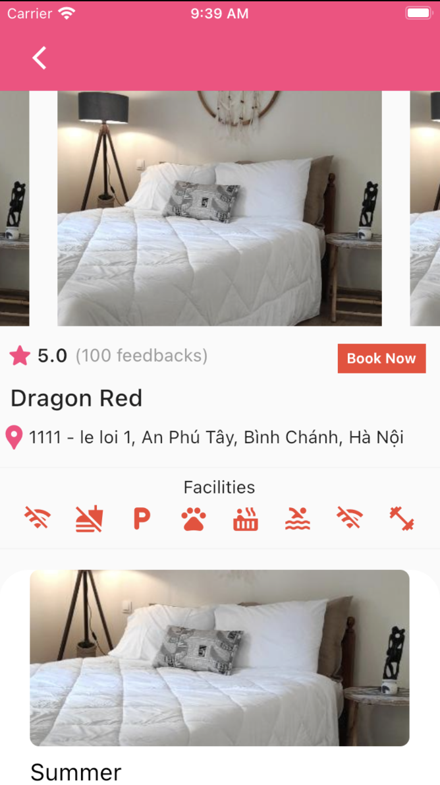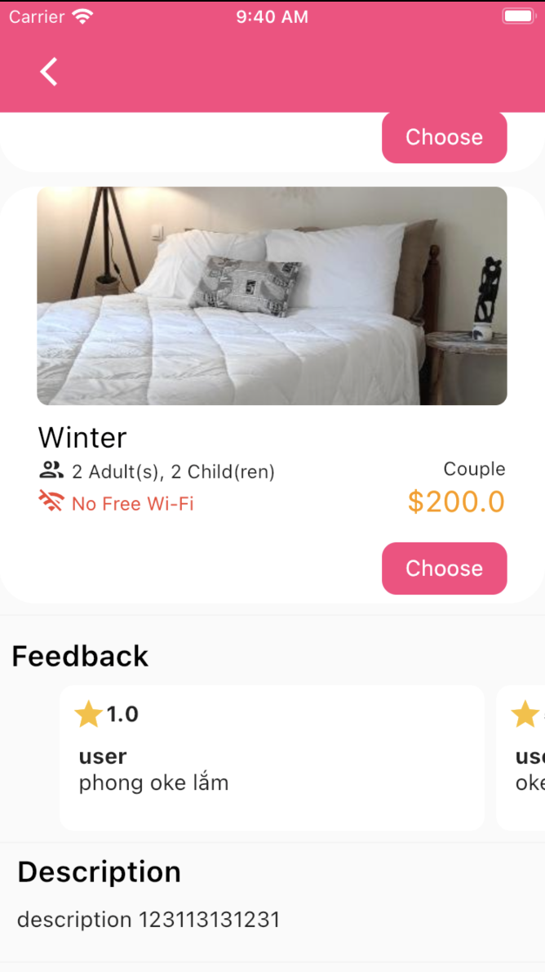

## HOTEL BOOKING PAGE

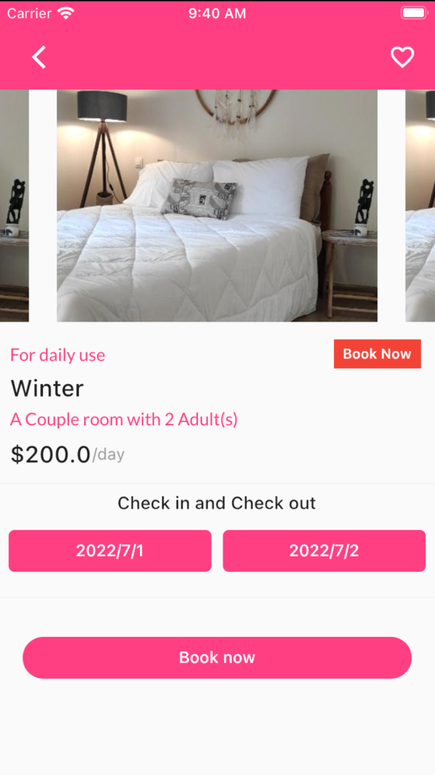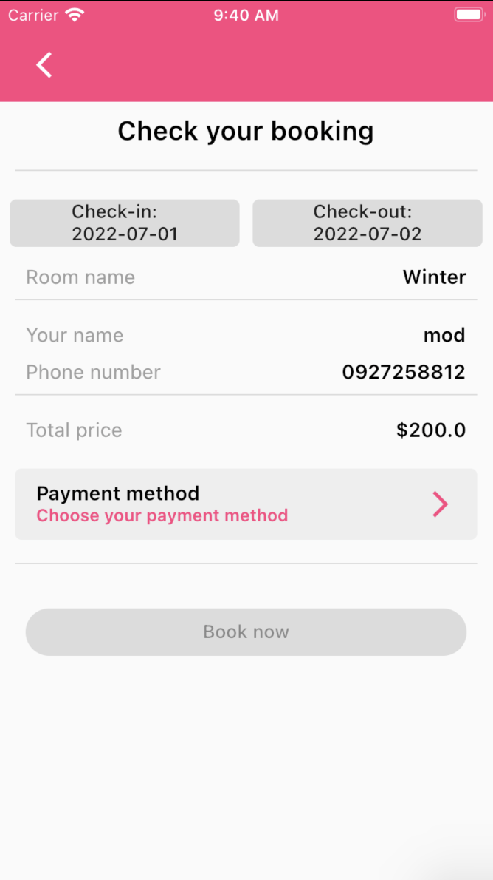

## COMPLETE BOOKING PAGE

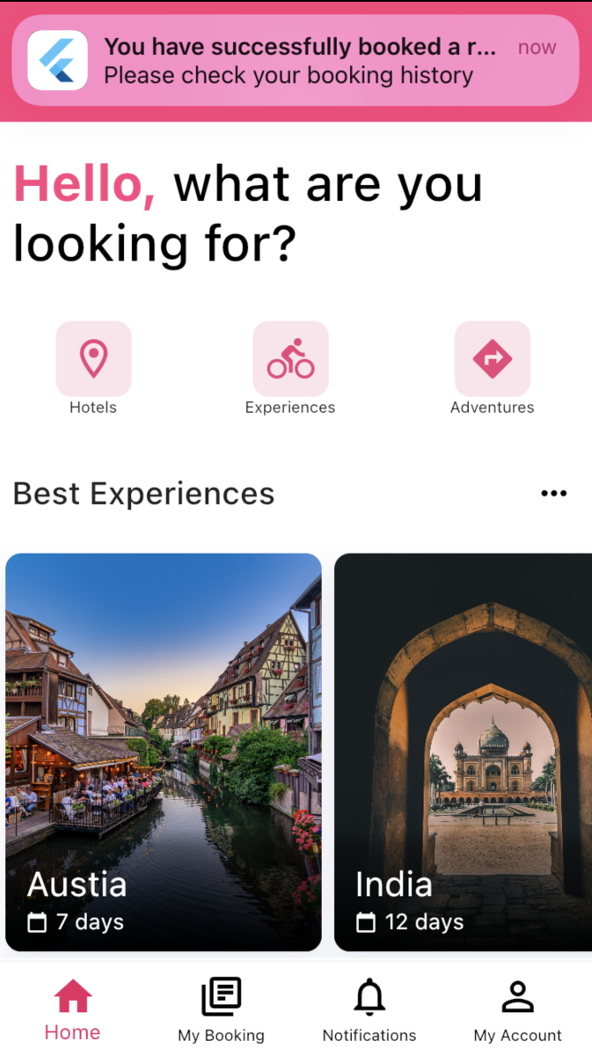

## LOGIN PAGE

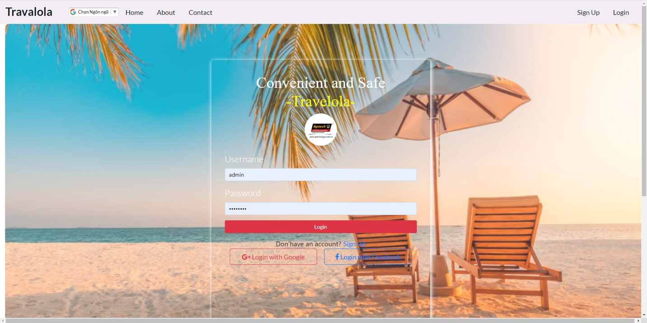

|  |  |  |  |  |  |
| --- | --- | --- | --- | --- | --- |
| **No** | **Name** | **Type** | **Validation** | **Description** | **Status** |
| 1 | Username | TextField | Not null | Enter username | Enable |
| 2 | Password | TextField | Not null | Enter password | Enable |
| 3 | Login | Click |  | Login button | Enable |
| 4 | Sign up | Click |  | Go sign up page | Enable |
| 5 | Login with Google/Facebook | Click |  | Login with Google/Facebook account | Enable |

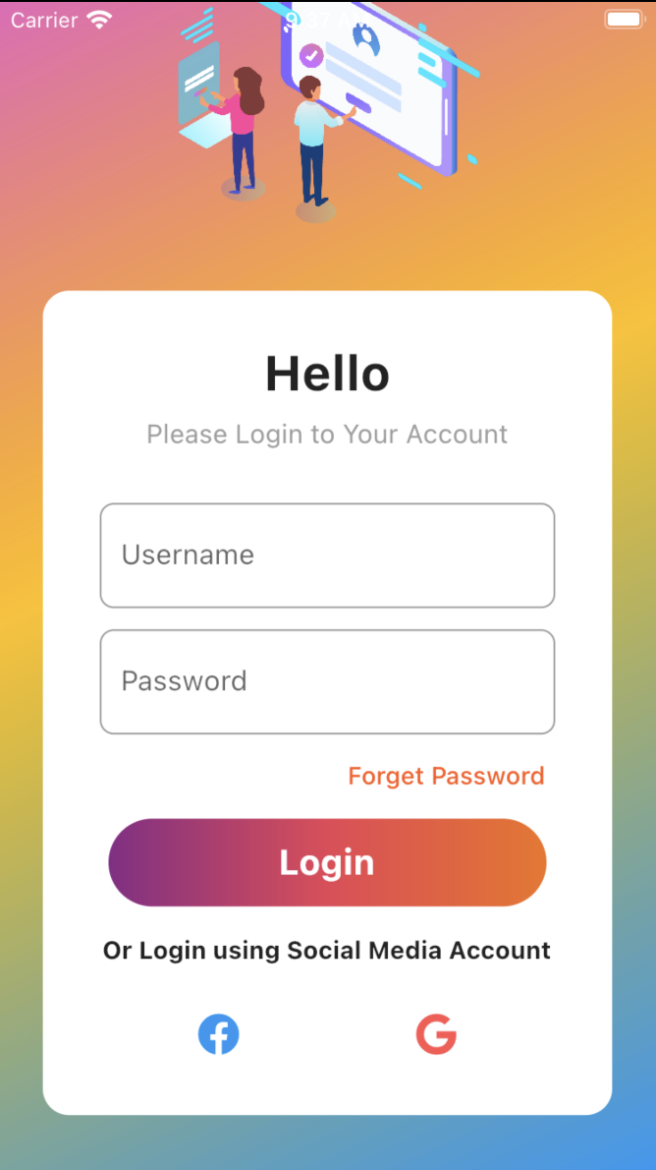

## REGISTER PAGE

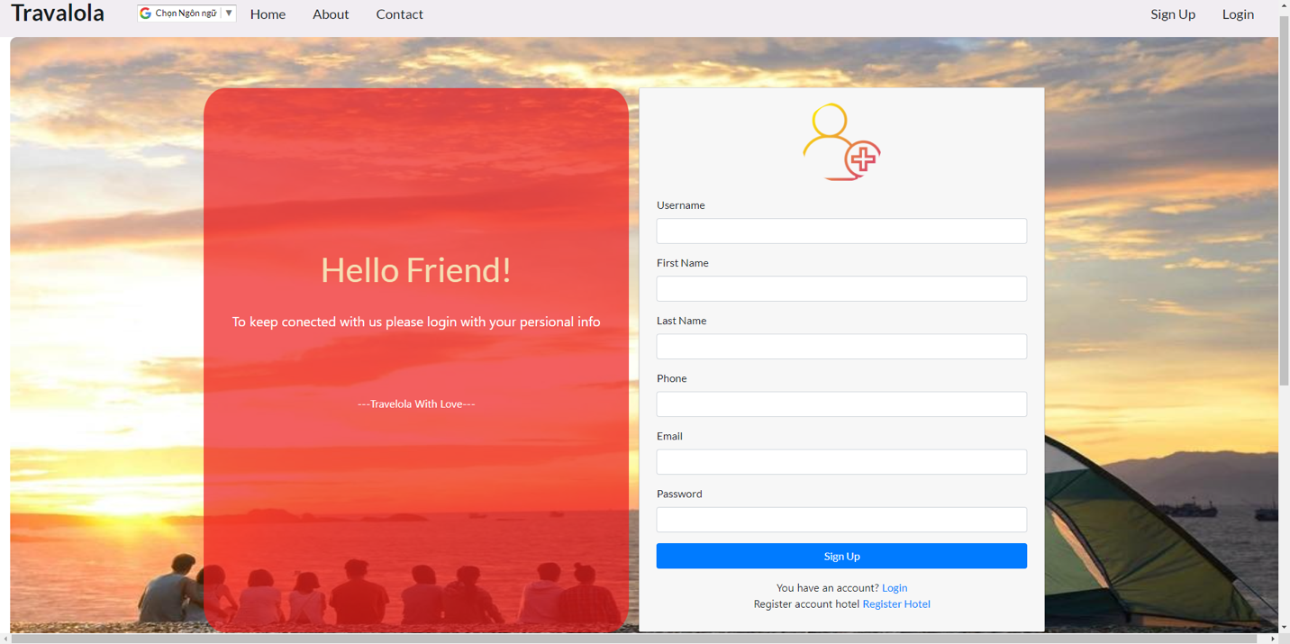

|  |  |  |  |  |  |
| --- | --- | --- | --- | --- | --- |
| **No** | **Name** | **Type** | **Validation** | **Description** | **Status** |
| 1 | Username | TextField | Unique,not null | Enter username | Enable |
| 2 | First name | TextField | Not null | Enter first name | Enable |
| 3 | Last name | TextField | Not null | Enter last name | Enable |
| 4 | Phone | TextField | Not null, phone must more than 8 | Enter phone number | Enable |
| 5 | Email | TextField | Not null, email validation | Enter email | Enable |
| 6 | Password | TextField | Not null | Enter password | Enable |
| 7 | Sign up | Click |  | Go sign up page | Enable |
| 8 | Login | Click |  | Login button | Enable |
| 9 | Register Hotel | Click |  | Go sign up a hotel | Enable |

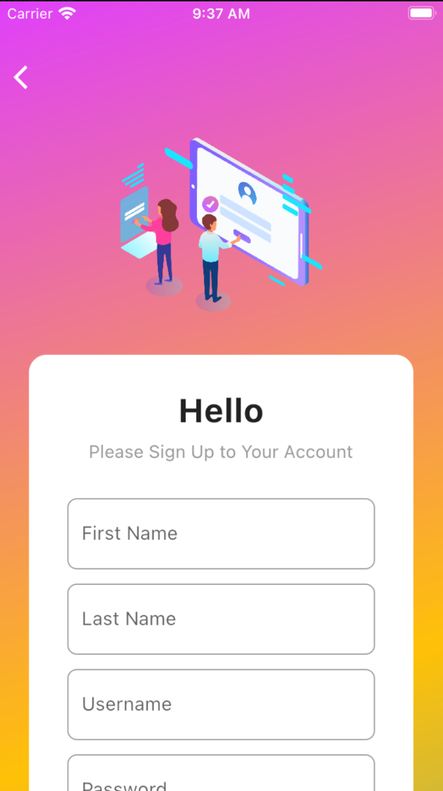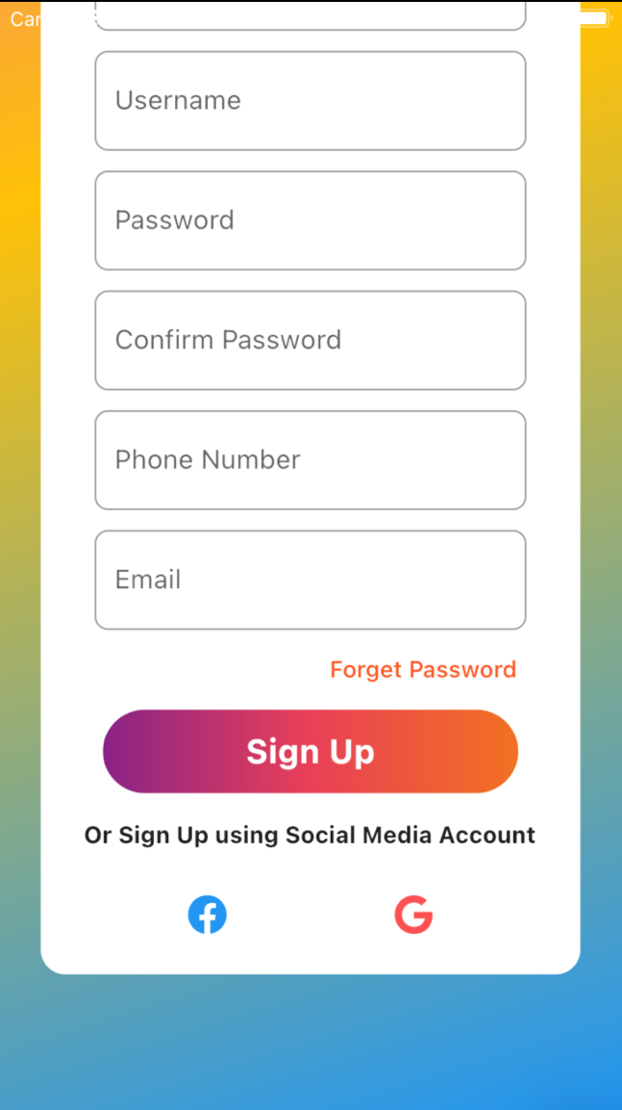

## HOTEL REGISTER PAGE

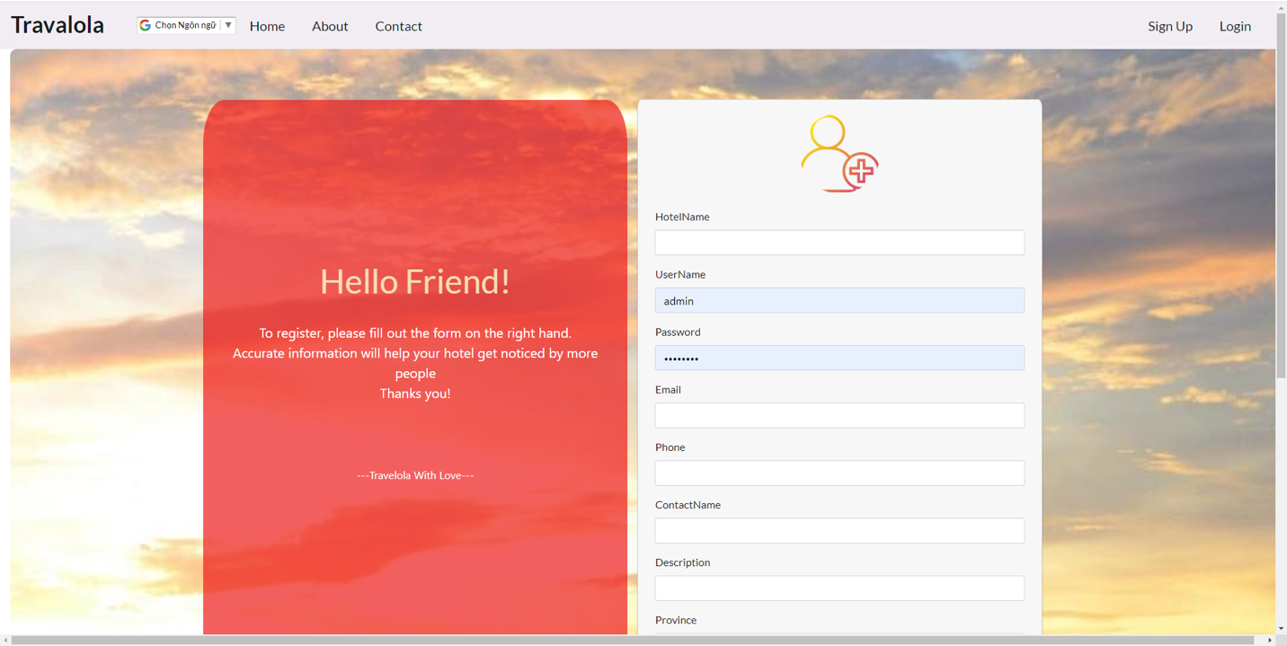

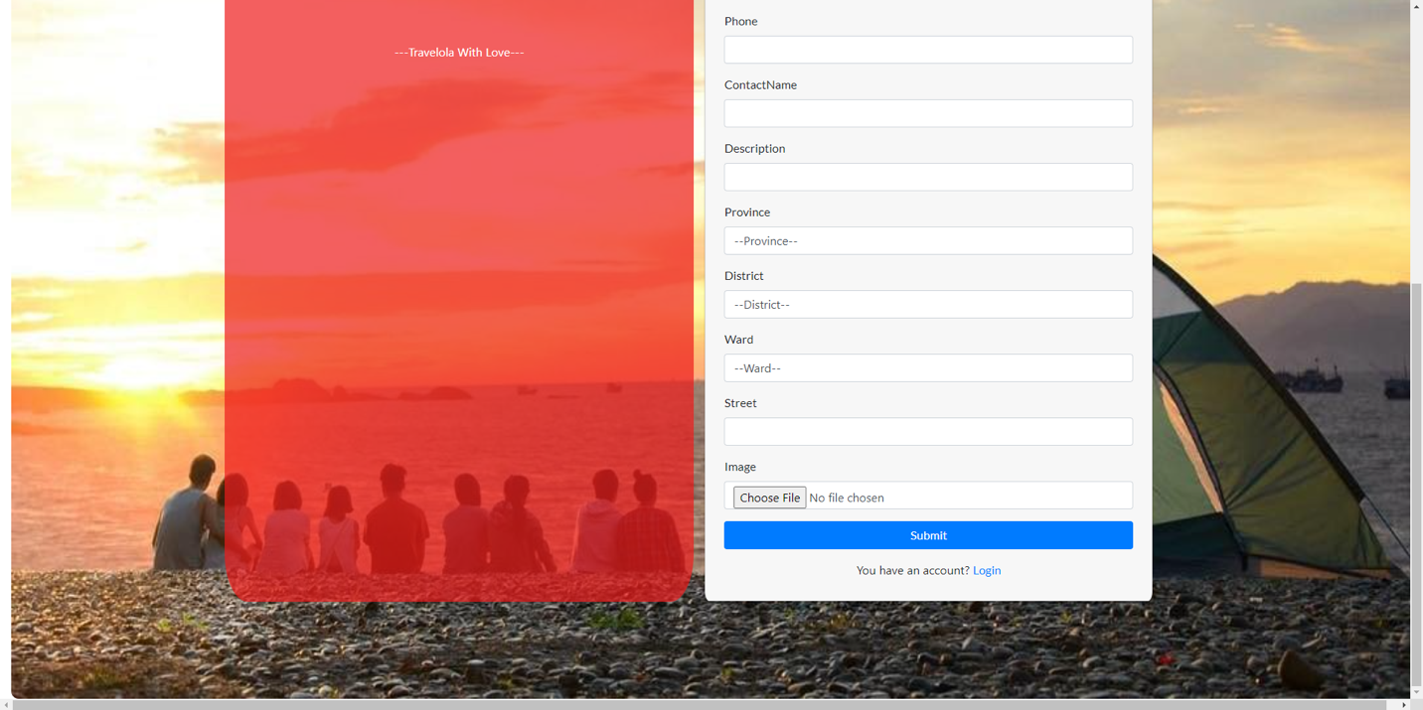

|  |  |  |  |  |  |
| --- | --- | --- | --- | --- | --- |
| **No** | **Name** | **Type** | **Validation** | **Description** | **Status** |
| 1 | Hotel name | TextField | Unique, not null | Enter hotel name | Enable |
| 2 | Username | TextField | Unique,not null | Enter username | Enable |
| 3 | Password | TextField | Not null | Enter password | Enable |
| 4 | Email | TextField | Not null, email validation | Enter email | Enable |
| 5 | Phone | TextField | Not null | Enter phone | Enable |
| 6 | Contact name | TextField | Not null | Enter contact name | Enable |
| 7 | Description | TextField | Not null | Enter description | Enable |
| 8 | Province | Click | Not null | Select province | Enable |
| 9 | District | Click | Not null | Select district | Enable |
| 10 | Ward | Click | Not null | Select ward | Enable |
| 11 | Street | TextField | Not null | Enter street | Enable |
| 12 | Image | Click | Not null | Select image | Enable |
| 13 | Submit | Click |  | Submit button | Enable |
| 14 | Login | Click |  | Go login page | Enable |

## ADMIN PAGE

## HOTEL MANAGER PAGE

## PROFILE USER

## 

|  |  |  |  |  |  |
| --- | --- | --- | --- | --- | --- |
| **No** | **Name** | **Type** | **Validation** | **Description** | **Status** |
| 1 | Update | Click |  | Go update information | Enable |